***CSS LAB NO.1***

**Task No.1**

**VM1: 192.168.100.100**

**VM2: 192.168.100.101**

**VM3: 192.168.100.102**

**Task 1.a:**

promiscuous mode is on:

**Vm1 Seed Ubuntu:**

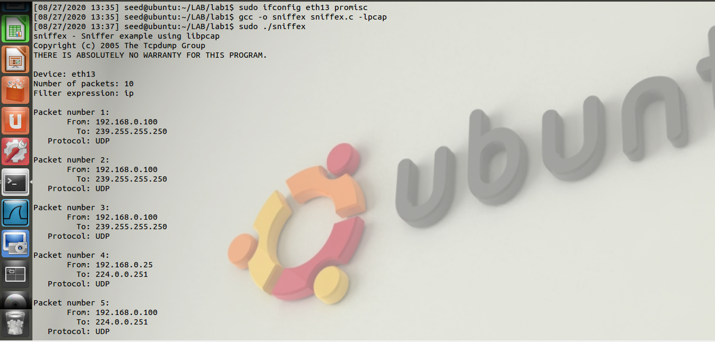

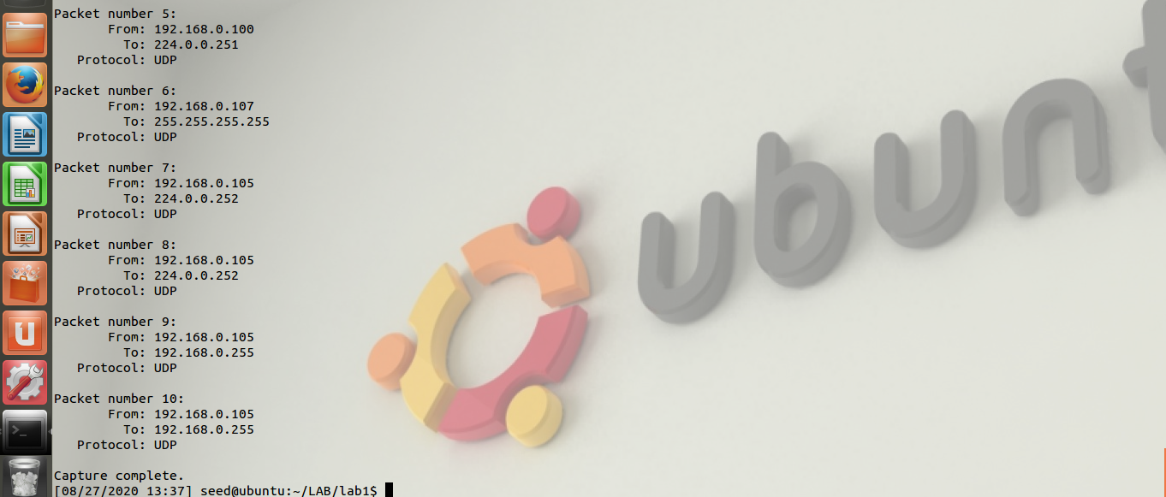

**Vm2 (Kali lunix)**

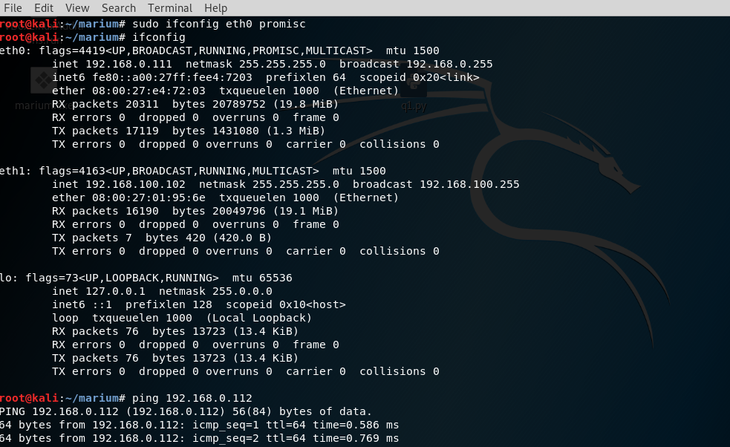

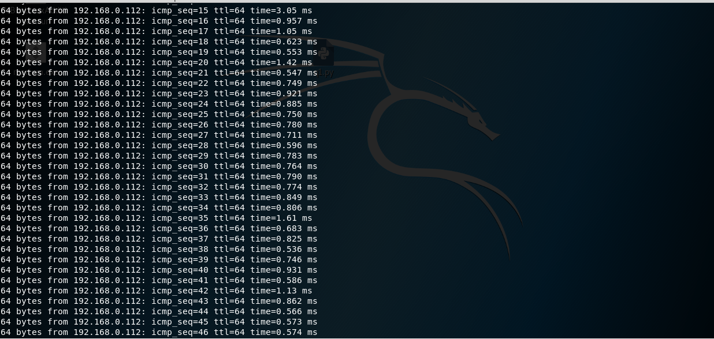

**VM3 (Ubuntu)**

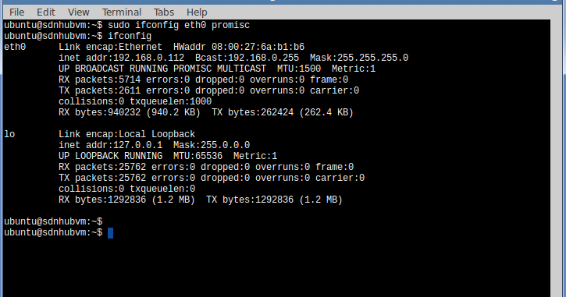

**Now pinging from Vm3 to Vm2**

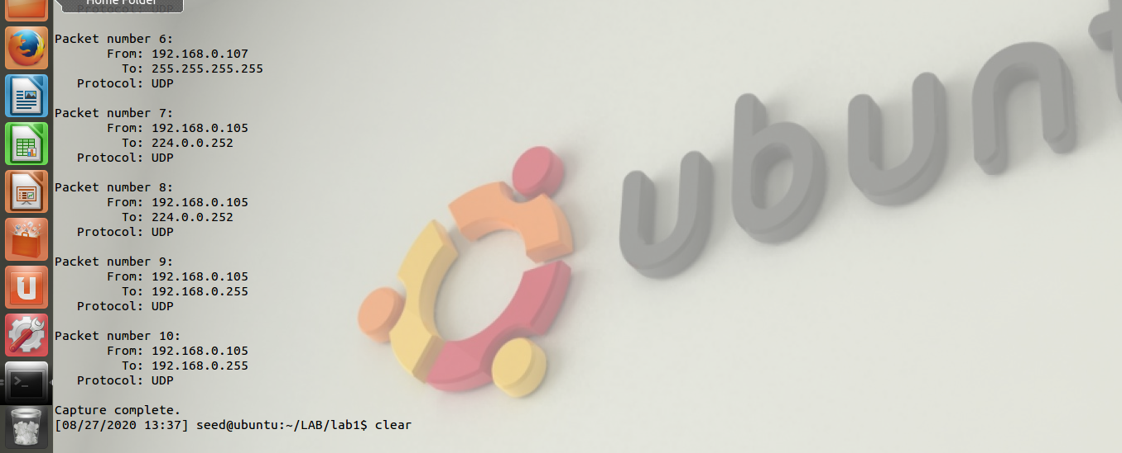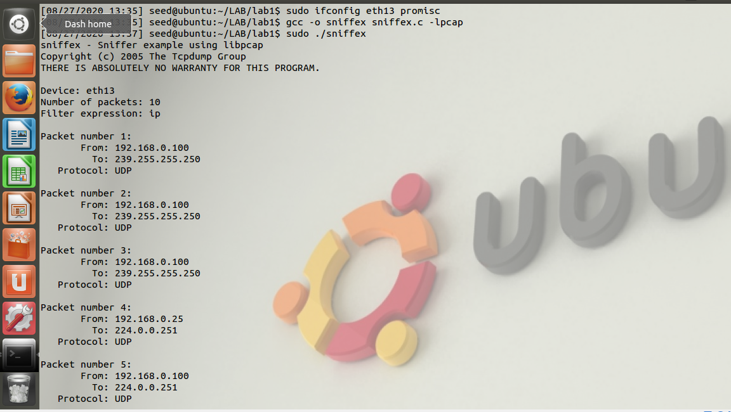

**Vm 3 (Ubutu )**

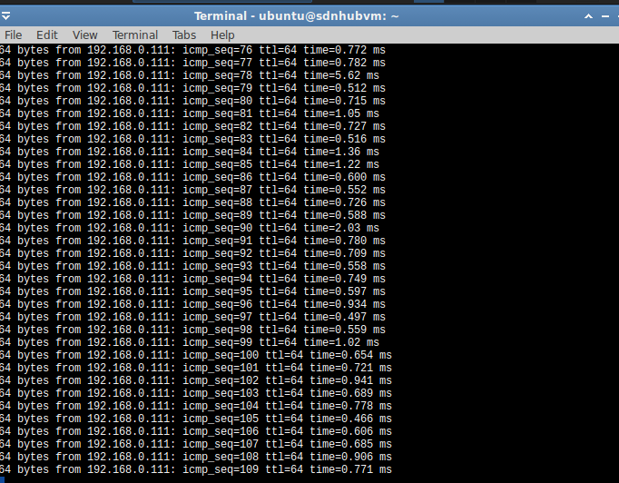

**Unsetting promiscous mode:**

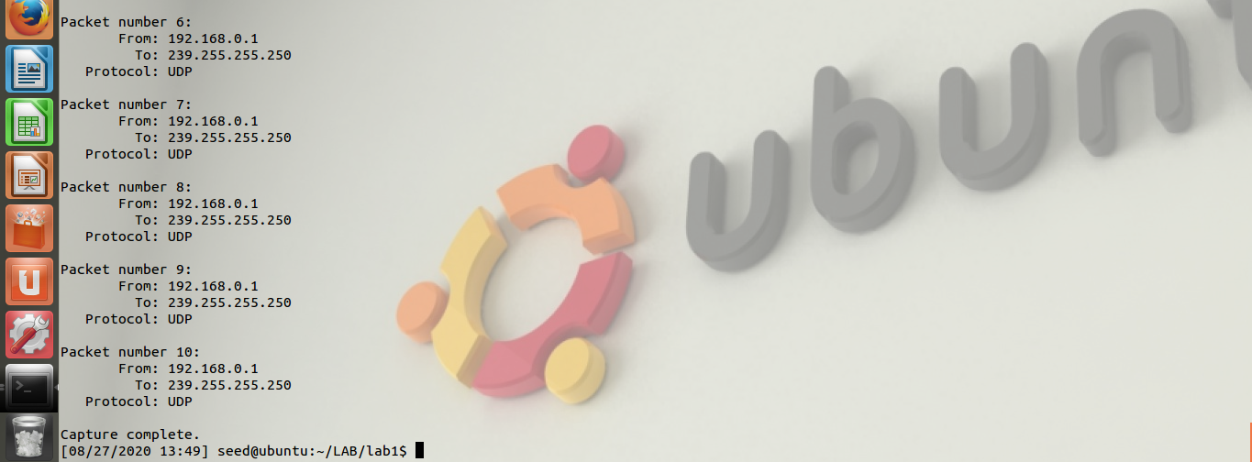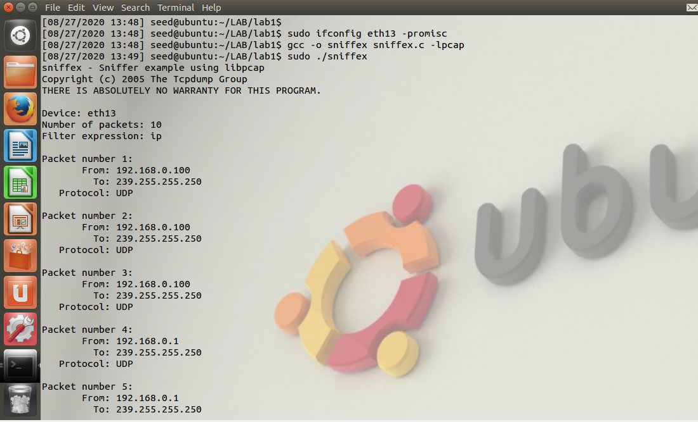

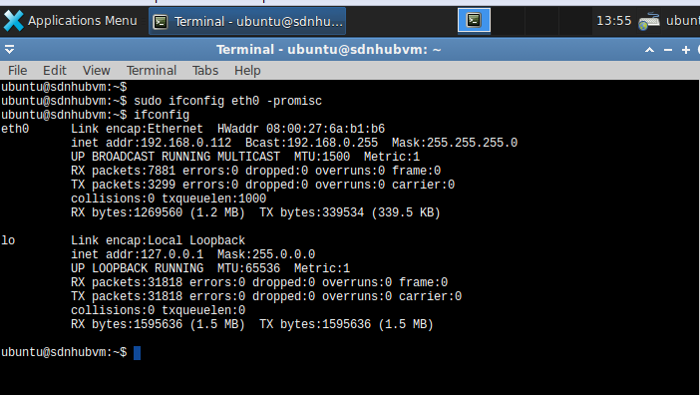**Vm2 (Ubuntu):**

**Vm 3(Kali Lunix):**

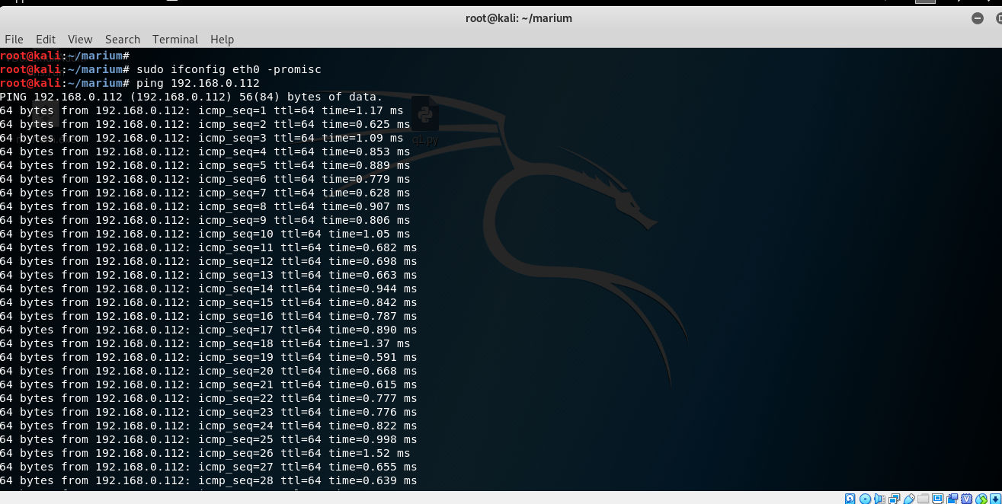

**Problem 1:**

**Please use your own words to describe the sequence of the library calls that are essential for sniffer programs:**

* • Ethernet interface that the program will utilize. (Such as eth13 in my case).
* • The initialization of the PCAP to create a session, typically there is on session per device to be sniffed.
* • The call to set traffic filtering rules, this ensures that the type of traffic sniffed on an interface is the type one is going for.
* • The execution of the sniff.
* • Termination of the session.

**Problem 2:**

**Why do you need the root privilege to run sniffex? Where does the program fail if executed without the root privilege?**

Pcap_lookupdev() function needs root access because it wants to access network interfaces and it is impossible without root access in linux. Sniffer programs need raw sockets that allow direct sending of packets by the applications bypassing all applications in network software of operating system. And we need to be a root to create raw socket as we can’t discover NIC until we are root.

**Problem 3:**

**Please turn on and turn off the promiscuous mode in the sniffer program:**

Screenshots are attached above.

**Can you demonstrate the difference when this mode is on and off? Please describe how you demonstrate this.**

Promiscuous mode is one in which all the packets are sent to a computer or sniffed by sniffer and not only those which are addressed to it whereas in a non-promiscuous mode only those packets are send to the computer or sniffed by sniffer which are addressed to it.

***TASK NO.2***

**On VM1,,rawudp.. Run the program rawudp.c on VM 1:**

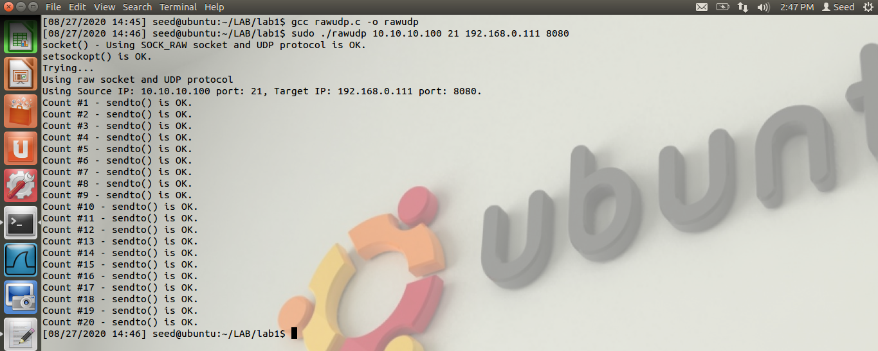

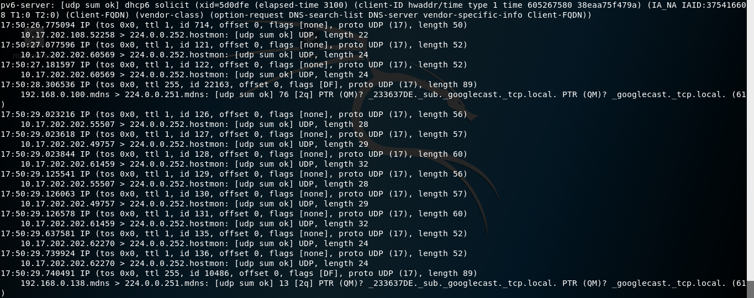**Verification on VM 2:** 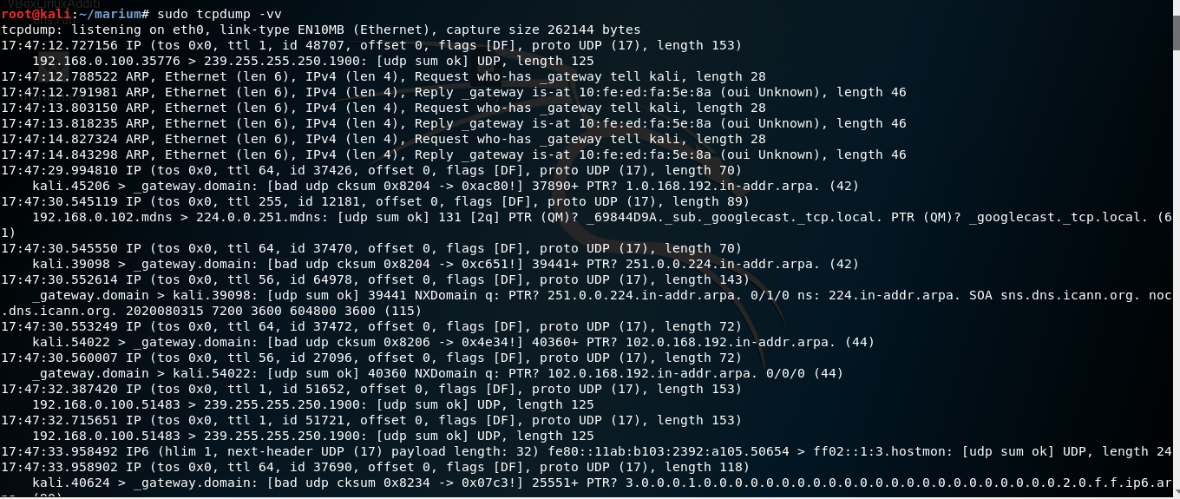

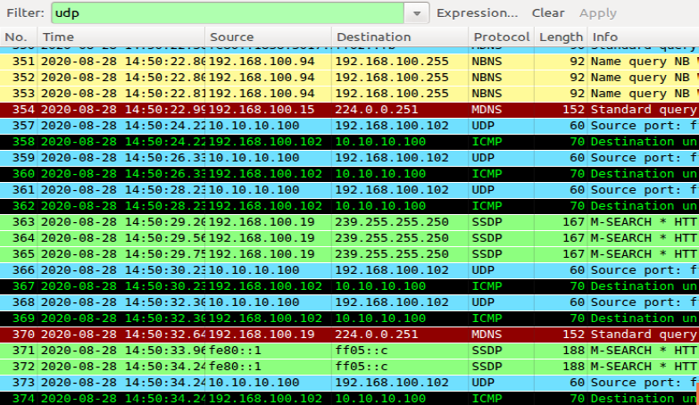

**Run the program rawtcp.c on VM 1:** 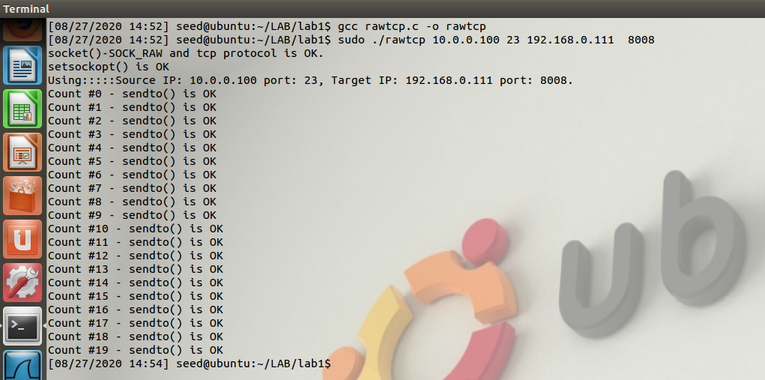

**Verification on VM 2:** 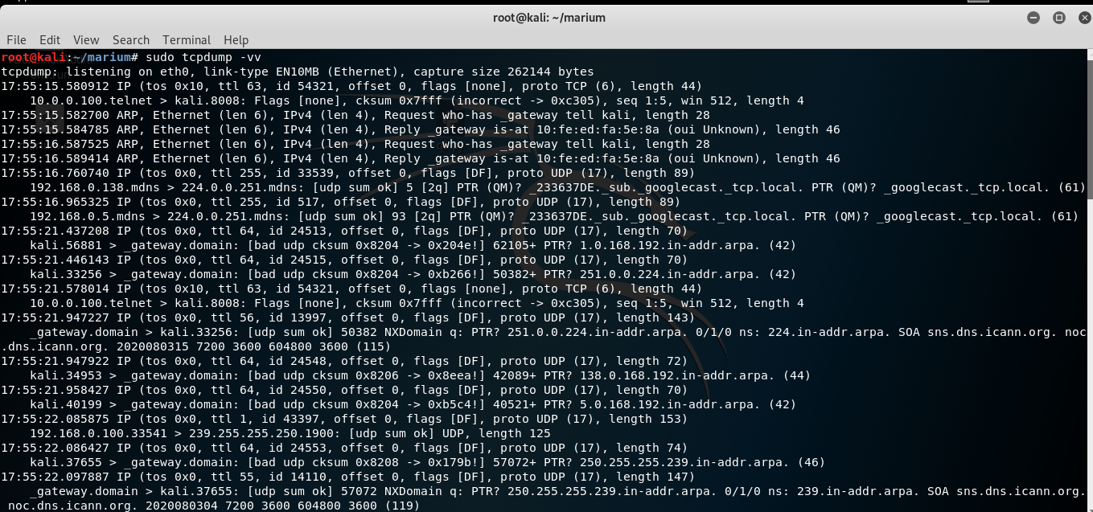

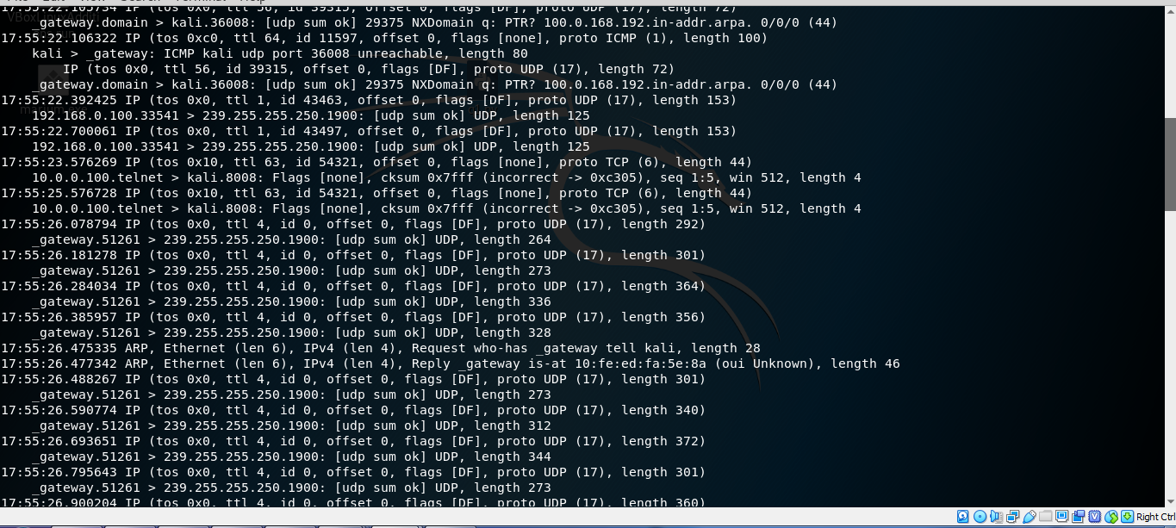

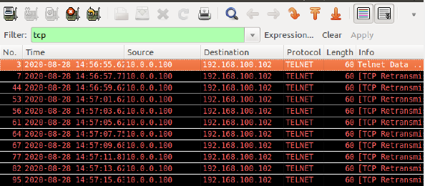

**Question 1:**

**Can you set the IP packet length field to an arbitrary value, regardless of how big the actual packet is?**

When sending a packet larger than its actual size, the additional data in the payload is a chunk of zeroes. Let say the TCP packet to google.com is (178.60.128.48). The payload is "ABC...XYZ", but the IP's *total_length* has been manually increased. The result is zero padding in the payload until completing the total length of the packet. So, the problem can be of *sendto* system call. This is the call that actually sends a packet on the socket. But this call also sets the *total_length* of the packet. If the *len* parameter on the *sendto* call has not been modified, so the packet's total length is overwritten to its original size when is sent.

**Question 2:**

**Using the raw socket programming, do you have to calculate the checksum for the IP header?**

No, the computer generally the system automatically does this, or rather it fills it in.

**Question 3:**

**Why do you need the root privilege to run the programs that use raw sockets? Where does the program fail if executed without the root privilege?**

In short this is how it is defined by the authorities who set networking rules. Due to the fact one can create custom packets that could prove detrimental to a network configuration